Name: __________________________________________ Date: _______________________

- Name and measure the angles.
B
E
F
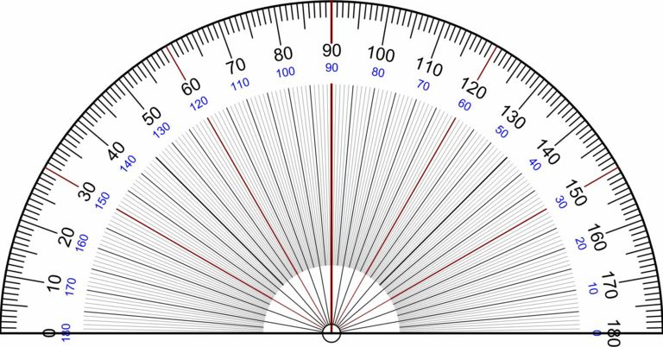
D
C
A
O
G

- Name two angles that are right angles.

- Name four angles that are acute angles. What are the measure of these angles?

- Name four angles that are obtuse angles. What are the measures of these angles?

- A polygon has the two perpendicular lines of symmetry shown. One quarter of the interior of the polygon is the shaded trapezoid drawn in. Sketch the completed polygon and give its geometric name based on the number of sides or angles it has.
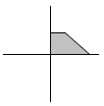

- Fill in the blanks with parallel, perpendicular, or intersecting in the appropriate places:
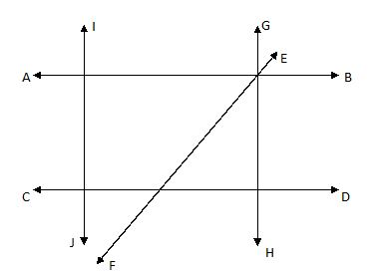

AB and CD are ________________ lines IJ and CD are ________________ lines
GH and AB are ________________ lines EF and GH are ________________ lines
AB and EF are ________________ lines GH and CD are ________________ lines
IJ and AB are ________________ lines EF and IJ are ________________ lines
GH and IJ are ________________ lines EF and CD are ________________ lines
- Find all the missing angles from the shapes below:
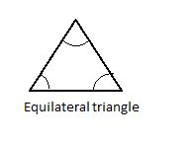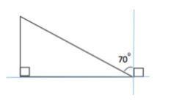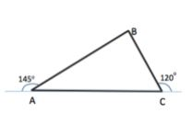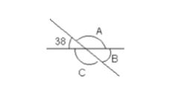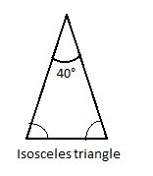
e.
d.
c.
b.
a.
- The length of a field shaped like a rectangle is 75m. Its width is 15m. If you run around the edge of the field 3 times. What distance would you have run?

- The area of a rectangular reaction area is 45 square miles. Its width is 5 miles. What is the length? Find the perimeter of the reaction area.
5 mi
? mi
area = 45 mi²

- A rectangular piece of paper measuring
15 cm by 7 cm is folded along the dotted lines to form the figure shown.

7cm
7cm
15cm
7cm
15cm
7cm

Find the area of the figure formed.

Bonus Problems
- The figure shows the front of a building with a triangular door. Find the area of the shaded part of the figure.
6 m
4 m
20 m m
12 m

- A rectangular pool is surrounded by a 2-yard-wide deck as shown in the diagram. Find the area of the deck.

2 yd
2 yd
2 yd
2 yd
18 yd
8 yd

Solutions

- a. Name two angles that are right angles.
<AOE <EOB <DOF

- Name four angles that are acute angles. What are the measure of these angles?
<AOC=20° <AOD=35° <COD=15° <COE=70° <DOE=55° <EOF= 35° <EOG=70°
<FOG=35° <FOB=55° <GOB=20°

- Name four angles that are obtuse angles. What are the measures of these angles?
<AOF=125° <AOG=160° <COF=105° <COG=140° <COB=160° <DOG=125° <DOB=145°

- A polygon has the two perpendicular lines of symmetry shown. One quarter of the interior of the polygon is the shaded trapezoid drawn in. Sketch the completed polygon and give its geometric name based on the number of sides or angles it has.
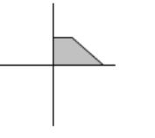
Hexagon; 6 sides; 6 angles.

3)

AB and CD are parallel lines IJ and CD are perpendicular lines
GH and AB are perpendicular lines EF and GH are intersecting lines
AB and EF are intersecting lines GH and CD are perpendicular lines
IJ and AB are perpendicular lines EF and IJ are intersecting lines
GH and IJ are parallel lines EF and CD are intersecting lines
4) Find all the missing angles from the shapes below:
a.
180-90-20 = 70°

d.
e.
142°
38°
180-38 = 142°
180-70-90 = 20°
b.
c..
70°
70°
60°
60°
60°
180-120 = 60°
180-60-35 = 85°
180-145 = 35°
5) The length of a field shaped like a rectangle is 75m. Its width is 15m. If you run around the edge of the field 3 times. What distance would you have run?

75 m
15m 15m

75m
Perimeter = 75 + 75 +15+15 = 180m
Running around the edge of a rectangle is the same as covering the perimeter of the field.
Covering the perimeter of the field 3 times = 180 x 3 = 540m
- The area of a rectangular reaction area is 45 square miles. Its width is 5 miles. What is the length? Find the perimeter of the reaction area.
5 mi
? mi
area = 45 mi²

Area = Length x width
45 = Length x 5
Length = 45/5
Length = 9 miles
Perimeter = 9 + 5 + 9 +5 = 28 miles
- A rectangular piece of paper measuring
15 cm by 7 cm is folded along the dotted lines to form the figure shown.

7cm
7cm
15cm
7cm
15cm
7cm

When the rectangular paper is folded along the dotted line it forms 2 right angled triangles with a base of 7 cm and height of 7 cm and a rectangle in the middle with a length of 7 cm and width of 1 cm.
Area of the triangles = ½ x 7 x 7 = 24.5 cm² each

Area of rectangle = 7 x 1 = 7 cm²

Area of the shape = 24.5 + 24.5 + 7 = 56 cm²
Solutions to Bonus Problems

- The figure shows the front of a building with a triangular door. Find the area of the shaded part of the figure.
6 m
4 m
20 m m
12 m

Area of the whole rectangle = Length x Width
= 20 x 12
= 240 m²

Area of the triangle = ½ x b x h
= ½ x 4 x 6
= 2 x 6
= 12 m²

Area of the shaded region = 240 m² – 12 m² = 228 m²

- A rectangular pool is surrounded by a 2-yard-wide deck as shown in the diagram. Find the area of the deck.

2 yd
2 yd
2 yd
2 yd
18 yd
8 yd

Area of the larger rectangle = length x width
= 22 x 12 = 264 yd²
Area of the smaller rectangle = 18 x 8 = 144 yd²
Area of the deck = 264 – 144 = 120 square yards

